St Michael’s Church,
Woolmer Green

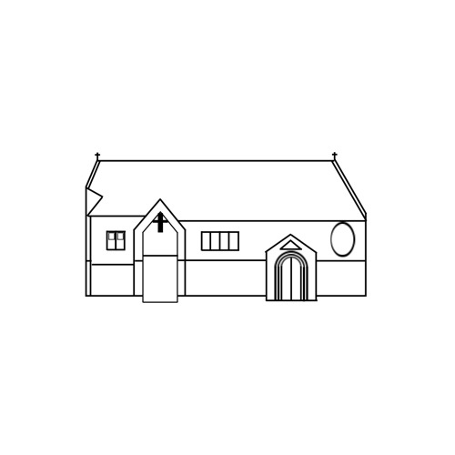

Churchyard Regulations

June 2018

Introduction to the Churchyard

The churchyard here in Woolmer Green is part of our Christian faith and heritage. Through consecration it is set apart for the reverent burial of parishioners, that is, those who have their names on the Electoral Roll or other persons who die in the parish. The Incumbent (the Team Rector) may also grant permission for the burial of other persons at his or her sole discretion.

Churchyards should be regarded as belonging to God, representing to us God’s love and compassion for the whole community. They need to be looked after to reflect the glory of God, for the benefit of all of God’s people today as well as those to come.

We are fortunate in Woolmer Green to have an open churchyard. This is something many parishes do not have the privilege of having since many churchyards are closed (i.e. full). In these instances, families have to rely on council-maintained cemeteries which can be some distance from the area where the parishioner lived.

There are two parts to the churchyard here at St Michael’s; there is the ‘old’ churchyard, and the newer extension north-east of the church.
Both areas allow for the burial of bodies and ashes.

To keep the churchyard’s peaceful ambience, and to reflect that peace which we find in God, there are certain regulations set by the diocese, and some of these are brought to your attention on the page overleaf.

Churchyard Conditions

- Burials are usually arranged through a funeral director, in liaison with the clergy. Sometimes, however, a burial of ashes is arranged directly with one of the clergy.

- The clergy have the right to decide where in the churchyard a particular burial or interment shall take place, except where a specific place has been reserved.

- Graves are usually marked by a simple wooden cross immediately after a burial. About a year after burial the grave should be levelled and once this is done an application may be made for the introduction of a memorial.

- The design of the memorial and its wording must comply with the diocesan regulations in force at that time. Most funeral directors and stone masons will be aware of these.

- Once a memorial stone is installed, the area should be grassed.

The following are not allowed in the churchyard:

- Artificial flowers
- Glass or plastic flower vases
- Planted flowers/trees/shrubs
- Windchimes or any other
ornaments
- Lights
- Photographs
- Planters
- Stones, chippings or surrounds
- Plastic wrappings from flowers

This is not an exhaustive list.
Fresh flowers are encouraged as a symbol of the gift of creation and the brevity of life, and these are best placed in a vase incorporated in the base of the headstone. Alternatively, a small pot may be placed on the base of the headstone. Bulbs are similarly encouraged as a symbol of resurrection.

The PCC (Parochial Church Council) has the right to remove dead and artificial flowers in order to keep the churchyard tidy.
The costs associated with burials and memorial applications are set nationally by the Church of England and are subject to change each year. The current figure can be obtained from one of the clergy, or on the Church of England website.

The purpose of this leaflet is not meant to be legalistic, but to make you aware of the rules which surround Church of England churchyards so that you can plan a permanent memorial which is both a fitting tribute and conforms to the Churchyard Regulations.

The clergy of St Michael’s can be contacted using the details below.

The Rector The Curate
The Reverend Dr David Munchin The Reverend Dominic Holroyd-Thomas
rector@welwyn.org.uk curate@welwyn.org.uk
01438 714150 01438 813043

Lord, now lettest thou thy servant depart in peace according to thy word.
For mine eyes have seen thy salvation,
Which thou hast prepared before the face of all people;
To be a light to lighten the Gentiles and to be the glory of thy people Israel.

The Nunc Dimittis
Luke 2: 29 - 32

